Title <Times New Roman 18 Bold>

James R. JonesAuthor1 <Times New Roman 14>
School, City, Country <Times New Roman 12, Italics>

William C. SmithAuthor2 <Times New Roman 14>
School, City, Country <Times New Roman 12, Italics>

Abstract text <Times new roman, 11, indent left 1cm, indent right 1/2cm , abstract should be less than 200 words, sentence case.>

Keywords: <times new roman, 11, indent left 1cm, indent right 1/2cm, up to six terms/phrases totaling 10 words or less, separated by semi-colon ; do not capitalize except proper nouns>

Introduction <ALL Top-Level Headings, Times New Roman 16, “Small Caps”, Title-Case, Double-Line Space Before Text>

<Times new roman 12, indent first line 1cm, do not double-space between paragraphs, double-space before next section heading or text>

Triangulation <Second-level Headings, Times New Roman 13, Bold, Title-Case, Double-Line Space Before Text>

<Times New Roman 12, indent first line 1cm, do not double-space between paragraphs, double-line space before next section heading or text>

Student Population<Third-level headings, times new roman 12, bold, sentence case, indent 1, no line space before new text (which is indented as above)>
Sentence text <Times New Roman 12, indent first line 1cm, do not double-space between paragraphs, double-space before next section heading or text>

This is a long quote of 40 or more words. Indent left 1cm and 0.5cm right. Use times new roman 11, with 1 blank line before this text and one blank line following. If a citation follows, include the citation within the sentence structure of the quote, or else place the citation in the text before the long quote (Jones & Smith, 2023, p. 13).

Table 1. Facebook Poll <Times New Roam 12, Title Case>
Question: What are the 3 most important services a teacher association should provide members/society? Tick no more than three, please. (This is part of a research project, I appreciate your inputs [sic]).
Response Items | Number of  Respondents | Percentage of  Responses
Workshops (local) | 44 | 31.4
Conferences/seminars/symposia | 32 | 22.9
Ideas sharing / mentoring | 30 | 21.4
Professional/scholarly publications | 13 | 9.3
Socialization | 8 | 5.7
Advocacy for relevant public policy | 6 | 4.3
Labor representation (union) | 4 | 2.9
Discounts in services beyond the society itself (bookstores, etc.) | 2 | 1.4
Vetted work opportunities | 1 | 0.7
Total Responses | 140 | 100
Note. Respondents = 56.

Figure 1. Korean Vowel Positioning <Times New Roman 12, Bold>
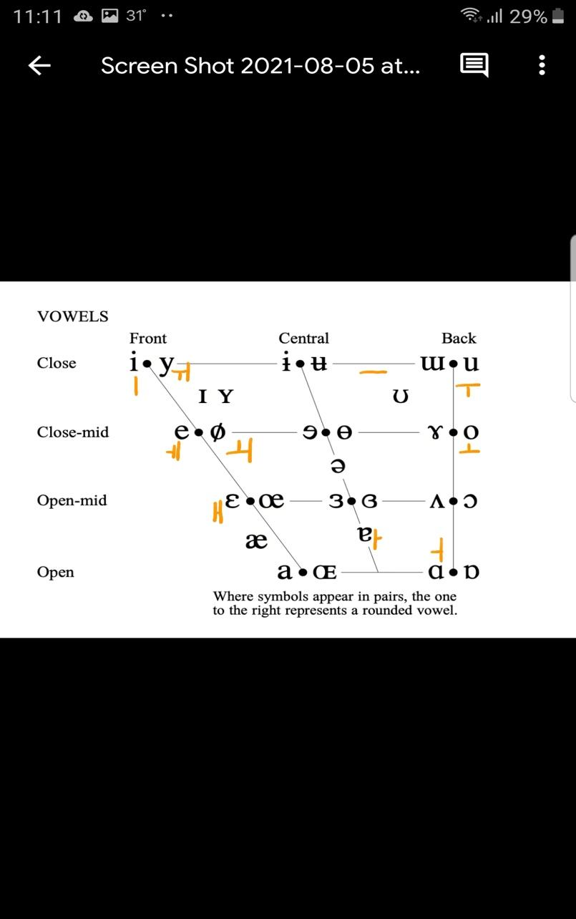

(Figures should be
Readable!)

Note. Adapted from IPA (2020). <”Note” is bold, italics. Text is neither bold nor italics, sentence-case, all times new roam 10>

Acknowledgements <Times New Roman 12, “Small-Caps,” Bold>

The author acknowledges (Non-authors (colleagues, friends, supervisor, etc.); Funding sources; Editing services, Administrative staff; Study registration; Data sharing, Any disclaimers). <Times new roman 11, sentence case, no indent>

The Authors <Times New Roman 12, “Small-Caps,” Bold>

James R Jones teaches at... Email: JRJ@mail.com, ORCID: <Times new roman 11, sentence case, no indent – name is bolded. Email optional, ORCID optional.>

William C Smith is a researcher at… Email: WCSmith@university.edu, ORCID <Times new roman 11, sentence case, no indent – name is bolded. Email optional, ORCID optional.>

Authors’ Contributions <Times New Roman 12, “Small-Caps,” Double-Line Space before Text>

JRJ – Conceptualization, Research Design, Data Collection, Data Analysis & Evaluation, Manuscript Writing <Times new roman 11, sentence case, no indent>

WCS – Statistical Analysis, Evaluation. <Times new roman 11, sentence case, no indent>

Authors’ Note <Times New Roman 12, “Small-Caps,” Double-Line Space before Text>

All authors declare that they have no conflicts of interest. The authors… <Times new roman 11, sentence case, no indent>

Notes <Times New Roman 12, “Small-Caps,” Double-Line Space Before Text>

1. This is the text for an end note – notes are discouraged. <Times new roman 11, “hanging indent” 1cm, enumeration to match in-text notation, no automated notations, right margin NOT justified (ragged)

References <Times New Roman 12, “Small-Caps,” Double-Line Space Before Text>

Aubrey, J., & Coombe, C. (2010). The TESOL Arabia conference and its role in the professional development of teachers at institutions of higher education in the United Arab Emirates. Academic Leadership Journal, 8(3). https://scholars.fhsu.edu/alj/vol8/iss3/53/
<Times new roman 11, “hanging indent” 1cm, activate hyperlinks, right margin NOT justified (ragged), references in APA style!>

Appendix 1<CENTERED (not margin left), Enumerate (1, 2, 3, etc if more than one), Times New Roman 12, “Small-Caps,” Double-Line Space Before Text>

No formatting requirements for Appendices text(s)

